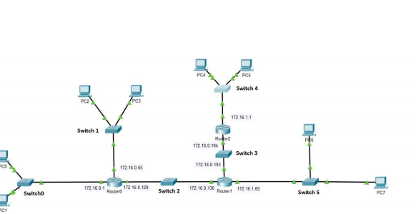

6 netwerken -> elk stukje na een router

X

|  |  |  |  |  |  |  |
| --- | --- | --- | --- | --- | --- | --- |
|  |  |  |  |  |  |  |
|  |  |  |  |  |  |  |
|  |  |  |  |  |  |  |
|  |  |  |  |  |  |  |
|  |  |  |  |  |  |  |
|  |  |  |  |  |  |  |
|  |  |  |  |  |  |  |